**Modified Lesson Plan- Direct Instruction**

**Author:**

Tracy Baird Empsall (Modified from Building Fiction: Elements of a Short Story)

**Date Created:**

12 February 2014

**Subject:**

English Literature

**Topic or Unit of Study:**

Plotting Plot

**Grade Level:**

9th Grade

**Materials:**

This lesson requires a white board, and poster paper and markers for the students. For independent practice, students will need Worksheet A, Worksheet B, Rubric A, their textbook or a copy of Richard Connell’s “The Most Dangerous Game,” and blank paper.

**Summary:**

The teacher will use a well-known children’s story to go over the elements of plot, and then the students will apply their knowledge of plot to a familiar work of fiction as well as a work from our classroom reading.

**I. Focus and Review:** [5 minutes]

Have students think of some stories they enjoyed as a child; they could be short stories, fairy tales, or even movies. Let the students pair up to discuss some of their favorites and give his or her partner at least two reasons as to why they liked them.

**II. Statement of Instructional Objective(s) and Assessments:**

|  |  |
| --- | --- |
| **Objectives** | **Assessments** |
| 1. After being introduced to the elements of plot, students will be able to apply them to a familiar story.  2. After reading a short story, the student will be able to summarize all five of the elements of the story’s plot onto a plot diagram in correct order.  3. After watching a movie or television show of their choice, the student will be able to summarize all five of the elements of the show’s plot onto a plot diagram in correct order. | 1. Students will place in small groups to complete a plot diagram as it applies to a chosen children’s story.  2. Students will read Richard Connell’s “The Most Dangerous Game,” and then complete a plot diagram naming and summarizing all five of the elements of plot.  3. Students will watch a movie or television show of their choice, and then create their own plot diagram, which must include five elements of plot in correct order. |

**State the objective:**

1-2 minutes will be devoted to presenting the objectives to the students and they will be clearly written on the board for the students to refer back to during the lesson.

**Assessment:**

Assessment 1 will be a part of guided practice, and students will be given 15 minutes to complete.

Assessment 2 will be assigned as independent practice and will be due at the beginning of the next class.

Assessment 3 will be assigned as independent practice and will be due at the end of the week.

**III. Teacher Input:**  [25 minutes]

The instructor is to teach the following information using the slide presentation at <http://prezi.com/oi_6gfc4molz/exposition/>

Traditional short stories follow a plot, and each plot is made up of five elements:

Exposition

Rising Action

Climax

Falling Action

Resolution

Use the plot diagram (From Plotting a Short Story) to show students how the main events in a story are organized into a plot.

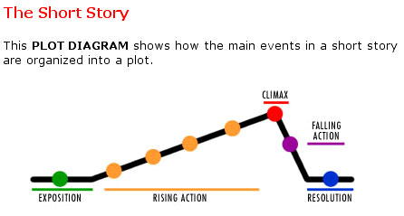

Exposition:

This is the beginning of the story. Here the characters and setting are introduced. The conflict is also introduced as part of the exposition.

Rising Action:

Here the conflict is dealt with through some kind of action; the main character is in crisis. All these events lead up to the climax.

Climax:

This is the high point of the story. Here the main character faces their worst challenge; at this point it looks as if the character will fail and becomes the turning point in the story.

Falling Action:

Here the story begins to wind down and shows the result of the actions or decisions the character has made.

Resolution:

This is often called *denouement*, which is French for unraveling or to untie, and is the conclusion of the story. Here all the conflicts are resolved.

Now, ask the class to supply the main events of the well-known story, Cinderella. Plot the elements on the white board as they occur (Taken from Building Fiction: Elements of a Short Story):

Exposition:

Cinderella lives unhappily with her stepmother and two stepsisters; an invitation to a ball at the palace arrives.

Rising Action:

The step sisters prepare to go to the ball; a fairy godmother appears and gives Cinderella a gown to wear to the ball and coach and footmen to take her there; she goes to the ball and dances with the prince; she leaves at midnight, losing a slipper on the steps; the prince finds the slipper and agrees to marry the woman whom it fits.

Climax:

The prince visits the home of Cinderella; the two sisters try to fit in to the slipper, but Cinderella appears and is discovered to be the wearer of the slipper.

Falling Action:

Cinderella and the prince prepare to marry.

Resolution:

They live happily ever after.

**IV. Guided Practice:** [20 minutes]

In small groups (about five students each), have students look back to the stories they shared at the beginning of class and pick one to chart on the Plot Diagram Template (Worksheet A).

Students can leave the Point of View and Conflict boxes empty.

Be sure to move from group to group to keep students on task and ask questions to gauge understanding.

After 15 minutes, ask students to share their plot diagrams and make corrections as needed.

***V.* Closure:** [15 minutes]

Review the five elements of plot and make sure the students are able to name each element of plot and what order they occur. Use the popcorn method to have students name them and summarize them in order.

***VI.* Independent Practice:** [homework]

For homework due at the start of the next class meeting, the students will read Richard Connell’s short story, “The Most Dangerous Game.” They will then create their own plot diagram using Worksheet B. The rest of the class period will be set-aside for students to begin reading the short story.

**The Most Dangerous Game**

**By Richard Connell**

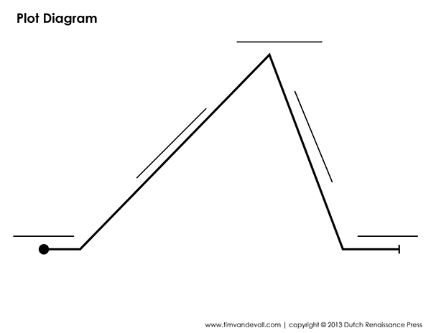

For homework due at the end of the week, the students will create their own plot diagram on blank paper. They will diagram the plot of a movie or television program they have recently seen. Rubric A shows the grading details.

**STANDARDS:**

9-10.RL.3 Analyze how complex characters (e.g., those with multiple or conflicting motivations) develop over the course of a text, interact with other characters, and advance the plot or develop the theme.

9-10.RL.5 Analyze how an author’s choices concerning how to structure a text, order events within it (e.g., parallel plots), and manipulate time (e.g., pacing, flashbacks) create such effects as mystery, tension, or surprise.

9-10.RL.10 By the end of grade 9, read and comprehend literature, including stories, dramas, and poems, in the grades 9-10 text complexity band proficiently, with scaffolding as needed at the high end of the range.

9-10.SL.1 Initiate and participate effectively in a range of collaborative discussions (one-on-one, in groups, and teacher-led) with diverse partners on grades 9–10 topics, texts, and issues, building on others’ ideas and expressing their own clearly and persuasively.

Technology: HS.TT.1 Use technology and other resources for assigned tasks.

**Plans for Individual Differences:**

Through observations of students’ understanding during the teacher input and guided practice sections, the instructor will form groups of varying skills and achievement levels to help students with their learning opportunities and differentiate the lesson. Lecture notes can be provided to students with difficulties writing notes or any students who request them as well. Also, students who have a hard time understanding the topic can be given another copy of Worksheet A instead of Worksheet B.

**References:**

Unknown author (2007). Building Fiction: Elements of a Short Story. *Teaching Today: Teaching Tips, Lesson Plans & More.* Retrieved from http://web.archive.org/web/20101010062453/http://teachingtoday.glencoe.com/lessonplans/building-fiction-elements-of-a-short-story

Cobb Erin (2013). Plot Diagram Graphic Organizer Template. *Teachers pay Teachers: an open marketplace for educators.* Retrieved from http://www.teacherspayteachers.com/Product/Plot-Diagram-Graphic-Organizer-Template-550103

Hall. Plotting a Short Story. *Engrade.* Retrieved from https://wikis.engrade.com/plottingashortstory

Worksheet A



Worksheet B



**The Most Dangerous Game**

**By Richard Connell**

Rubric A

**Plot Diagram**

Name:_____________________________________

Movie/Television Show:_____________________________________

|  |  |  |  |  |
| --- | --- | --- | --- | --- |
|  | 4 | 3 | 2 | 1 |
| Plot Elements | All five elements of the plot are labeled on the diagram in correct order. | Four elements of the plot are labeled on the diagram. | Two or three elements of the plot are labeled on the diagram. | One element of the plot is labeled on the diagram. |
| Exposition | The setting, conflict introduction, and two or more characters are included in the exposition section of the diagram. | The setting, conflict introduction, and one character are included in the exposition section of the diagram. | Two of the parts of the exposition (setting, character, conflict) are included in the diagram. | One of the parts of the exposition (setting, character, conflict) is included in the diagram. |
| Rising Action | Four or more events are listed in the rising action section of the diagram. | Three events are listed in the rising action section of the diagram. | Two events are listed in the rising action section of the diagram. | One event is listed in the rising action section of the diagram. |
| Color | Five or more colors are included in the diagram. | Four colors are included in the diagram. | Three colors are included in the diagram. | Two or fewer colors are included in the diagram. |
| Spelling/Grammar | There are no spelling or grammar mistakes on diagram. | There are one or two spelling or grammar mistakes on diagram. | There are three or four spelling or grammar mistakes on diagram. | There are five or more spelling or grammar mistakes on diagram. |

Total: ____/20