Modified Lesson Plan- Concept Development

Author:
Tracy Baird Empsall
Date Created:
14 February 2014
Subject:
English Literature
Topic or Unit of Study:
Understanding Types of Conflict
Grade Level:
9th Grade

Materials:
This lesson requires a white board, four sheets of poster paper, and notebook paper for the students. For independent practice, students will need their textbook or a copy of Saki’s “The Interlopers,” and each will need copies of the handouts attached. If the classroom has a Smart Board, this lesson can be done without the poster paper.

Summary:
The teacher will guide students into realizing the different types of conflict by creating a list and then grouping like items. Students will use these groups they have created to label conflicts on a worksheet. They will then create a conflict storyboard illustrating one conflict in Saki’s “The Interlopers.”

I. Focus and Review: [10 minutes]
Review the five elements of plot with the students by going over their plot diagrams of Richard Connell’s “The Most Dangerous Game.” Focus on the rising action of the diagrams to have the students pull out the main conflict in the story. (Rainsford will not hunt humans with Zaroff, so Zaroff decides to hunt Rainsford.)

II. Statement of Instructional Objective(s) and Assessments:
Objectives | Assessments
1. When given a list of conflicts, students will be able to correctly identify what types of conflict they all are.  2. After reading a short story, students will be able to identify the different types of conflict and illustrate at least one of them. | 1. Students will be given an in-class worksheet with five conflicts, and they will have to correctly identify all of them as either Internal or External and Human VS Human, Human VS Self, Human VS  Society, or Human VS Nature.  2. Students will read Saki’s “The Interlopers,” and they will have to describe the Human VS Human, Human VS Self, and Human VS Nature conflicts shown in the story. Then they will choose one to illustrate as a storyboard.

State the objective:
1-2 minutes will be devoted to presenting the objective to the students and it will be clearly written on the board for the students to refer back to during the lesson.

Assessment:
Assessment 1 will be assigned as independent practice and will be completed in five minutes during class. They will be looked over right away, so the instructor is able to make corrections with individual students throughout the remaining class time.
Assessment 2 will be assigned as independent practice and will be due at the end of the week. See Rubric A for full directions and scoring guide.

III. Teacher Input: [20-30 minutes]
It isn’t everyday that another person decides to hunt you, but we do face certain types of conflicts throughout our everyday lives.

Have the students brainstorm different conflicts people face in their lives and write them down on their own paper; walk around the room to provide ideas when needed. Invite them to share conflicts they see in movies or read about in books as well as general conflicts from life; ask them to resist sharing too much personal information.

Once they have come up with a few on their own, have students form small groups where they are sitting to share their conflicts and create a group list. Have one member from each group write their group’s list on the whiteboard or blank Smart Board template. (If you have access to a Smart Board, please follow directions in orange.) While the students are writing, read over their conflicts; make a note of any types of conflict that are not represented by the student answers. Once the students have finished writing, add some conflicts to represent the missing types. (Make sure there are at least two for each category- Human VS Self, VS Human, VS Society, and VS Nature.)

Guide the students into grouping the conflicts that are alike in someway (lead them toward making two groups- Internal and External conflicts- but do not name the groups). Have students physically move the conflicts around the Smart Board to form the two groups. To save time, have one volunteer come to the board while the rest of the class instructs him or her where to move the conflicts. Once the students have broken up all the conflicts into two categories, ask them to define the reason they split them up; the students should be able to see one group (internal conflicts) only involves one person with no outside forces while the other (external conflicts) involves another person or an outside force. The class is to name each category based off of the reason they grouped the conflicts.

Once the class has labeled the two categories with a defining name, introduce them to the terms internal and external conflict.
Internal Conflict- A struggle that occurs within a character’s own mind (a
character struggles with mixed emotions, guilt, difficulty making a decision,
etc.).
External Conflict- A struggle that occurs between a character and an outside
force.
Ask students to match their title to the two new terms. Then have them focus on the class list of external conflicts.

Guide them to subcategorize the list of conflicts into three subgroups, have a new volunteer interact with the Smart Board by moving the conflicts around the board. Again have them to define the reason they split them up, and name each category based off of the reason they grouped the conflicts. Introduce them to the three types of external conflict:
Human VS Human
Human VS Society
Human VS Nature
Together, the students can now match their titles to the three different types of external conflict.

IV. Guided Practice: [10 minutes]
Have each student write two or more examples of each type of conflict (that are not already on the board) on their own paper. Walk around the room to gauge understanding and to make corrections as needed. Come back as a class, and have each student share a conflict from their list. One at a time, have the students in the rest of the class name the type of conflict the student shared.

V. Closure: [5 minutes]
Review the different types of literary conflict using Handout A and B (Retrieved from StoryboardThat).

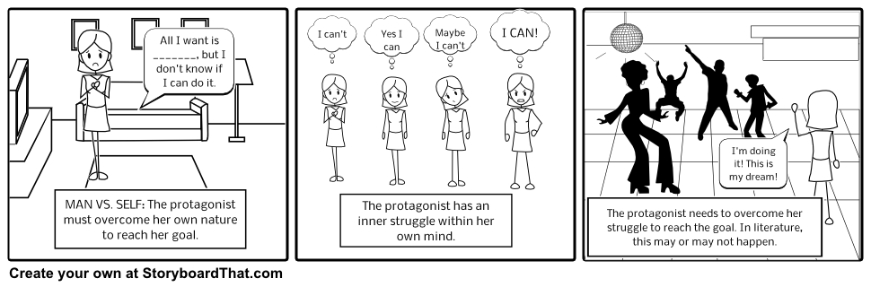

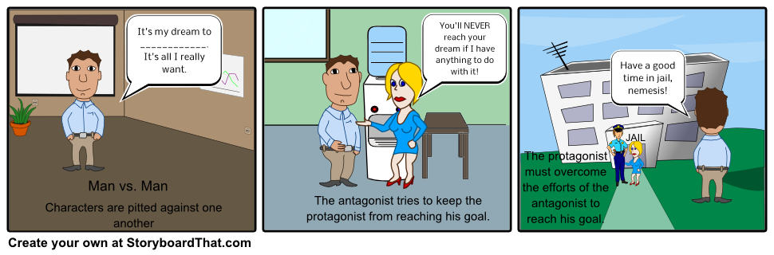
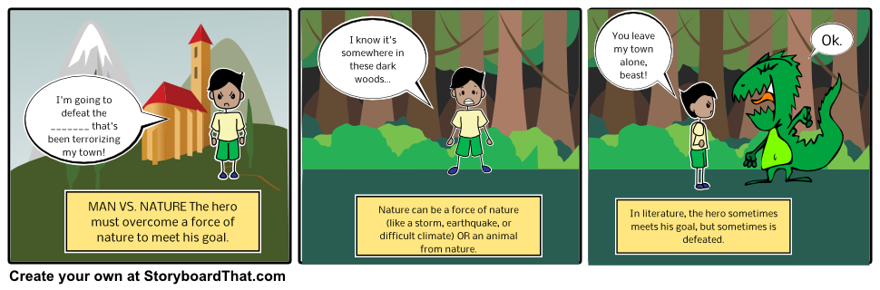
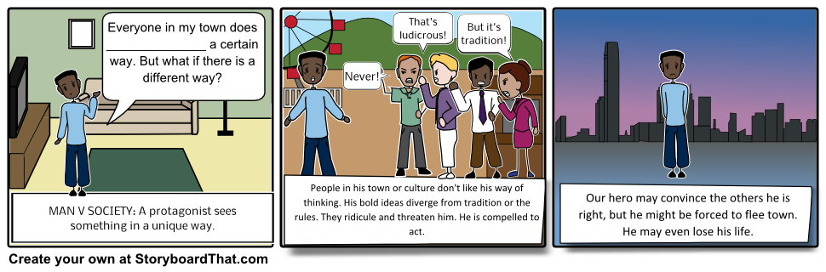

VI. Independent Practice: [5 minutes and homework]
Have the students complete the exit slips found on page 7. They should turn them in right away for the instructor to review.

The students will use the rest of class time to begin reading Saki’s “The Interlopers.”
As homework, the students will create a storyboard illustrating one of the conflicts found in Saki’s short story.

STANDARDS:
9-10.RL.3 Analyze how complex characters (e.g., those with multiple or conflicting motivations) develop over the course of a text, interact with other characters, and advance the plot or develop the theme.
9-10.RL.10 By the end of grade 9, read and comprehend literature, including stories, dramas, and poems, in the grades 9-10 text complexity band proficiently, with scaffolding as needed at the high end of the range.
9-10.SL.1 Initiate and participate effectively in a range of collaborative discussions (one-on-one, in groups, and teacher-led) with diverse partners on grades 9–10 topics, texts, and issues, building on others’ ideas and expressing their own clearly and persuasively.
HS.TT.1 Use technology and other resources for assigned tasks.

Plans for Individual Differences:
Exit slips will identify students who would benefit from additional support during the remaining class time. Students will also be reminded of previous concept attainment lessons, and by allowing students the choice of the concepts to be categorize, students will be able to manipulate the complexity, abstraction, and accessibility of the examples. However, the concept attainment model is inherently differentiated.

References:
Docimo, Katherine (2014). Types of Conflict Found in Literature. StoryboardThat. Retrieved from http://www.storyboardthat.com/articles/education/types-of-literary-conflict

Handout A

Handout B
Name: _____________________________________ Date: ___________________________

Conflict Check

Read the sentences below, and then circle the types of conflict that best describe what happened in the sentence.

1. Bob Barker and Jack Black are both running for president of the debate club.
Internal External Human vs. Human Human vs. Self
Human vs. Society Human vs. Nature

2. Alya feels both love and hate toward her school.
Internal External Human vs. Human Human vs. Self
Human vs. Society Human vs. Nature

3. Jamel was late to school because he slipped on the ice multiple times.
Internal External Human vs. Human Human vs. Self
Human vs. Society Human vs. Nature

4. Frankenstein is running from the villagers with torches and pitchforks.
Internal External Human vs. Human Human vs. Self
Human vs. Society Human vs. Nature

5. Gilligan and the Skipper can’t decide who gets dance with Ginger.
Internal External Human vs. Human Human vs. Self
Human vs. Society Human vs. Nature

Name: _____________________________________ Date: ___________________________

Conflict Check

Read the sentences below, and then circle the types of conflict that best describe what happened in the sentence.

1. Bob Barker and Jack Black are both running for president of the debate club.
Internal External Human vs. Human Human vs. Self
Human vs. Society Human vs. Nature

2. Alya feels both love and hate toward her school.
Internal External Human vs. Human Human vs. Self
Human vs. Society Human vs. Nature

3. Jamel was late to school because he slipped on the ice multiple times.
Internal External Human vs. Human Human vs. Self
Human vs. Society Human vs. Nature

4. Frankenstein is running from the villagers with torches and pitchforks.
Internal External Human vs. Human Human vs. Self
Human vs. Society Human vs. Nature

5. Gilligan and the Skipper can’t decide who gets dance with Ginger.
Internal External Human vs. Human Human vs. Self
Human vs. Society Human vs. Nature

Rubric A

Conflict in Saki’s “The Interlopers”

The woods, frenemies, and wolves! Oh my! Saki’s witty and macabre short story, “The Interlopers,” is chock full of conflicts.
Devote one paragraph (3-5 sentences) to each of the types of conflicts below. Explain how each is shown in the story.
Human VS Human
Human VS Self
Human VS Nature
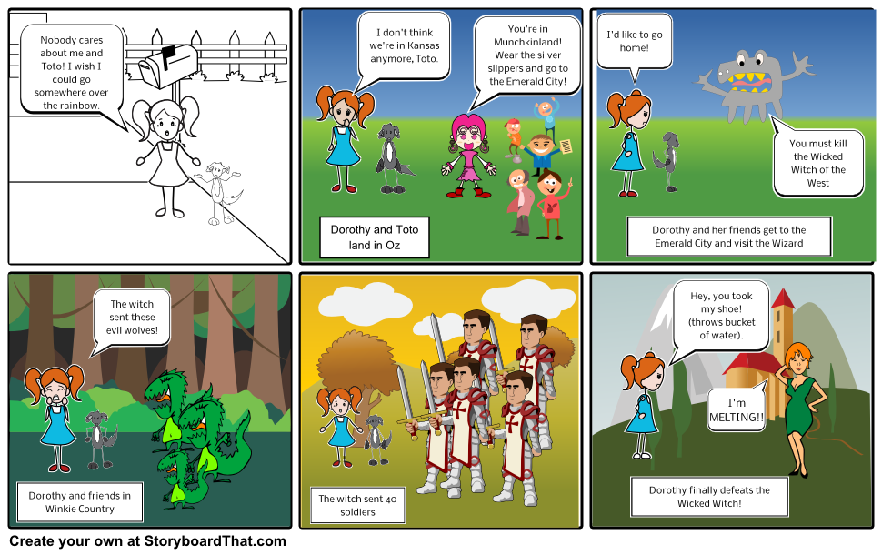
Once you have completed your three paragraphs, choose one conflict to illustrate as a storyboard, like this Human VS Human conflict in The Wonderful Wizard of Oz by L. Frank Baum.

You are encouraged to use StoryboardThat.com to create your storyboard, but you may hand draw it if you prefer. Just be sure to refer to the rubric when creating your conflict storyboard.

Conflict Storyboard
Name:_____________________________________
Chosen Conflict:_____________________________________

 | 4 | 3 | 2 | 1
Paragraphs | All three types of conflict are correctly identified and are clearly explained. | One type of conflict is incorrectly identified but all include explanations. | Two or more conflicts are not correctly identified but all include explanations. | Conflicts are identified but no explanations are given.
Conflict | One conflict from the story is clearly shown in the storyboard and includes at least two quotes from the story. | One conflict from the story is clearly shown in the storyboard and includes one quote from the story. | One conflict from the story is clearly shown in the storyboard. No quotes from the story are included | The conflict in the storyboard is not clearly shown.
Boards | Storyboard is made of four or more boxes. | Storyboard is made of three boxes. | Storyboard is made of two boxes. | Storyboard only contains one box.
Color & Neatness | Storyboard is colorful and neat, making it easy to read. | Storyboard is neat but not colored. | Storyboard is colored but not neat. | Storyboard is not colored and is difficult to read.
Spelling & Grammar | There are no spelling or grammar mistakes in the paragraphs or on the storyboard. | There are one or two spelling or grammar in the paragraphs or on the storyboard. | There are three or four spelling or grammar mistakes in the paragraphs or on the storyboard. | There are five or more spelling or grammar mistakes in the paragraphs or on the storyboard.

Total: ____/20

